ANSWERS FOR ISSSUE #2

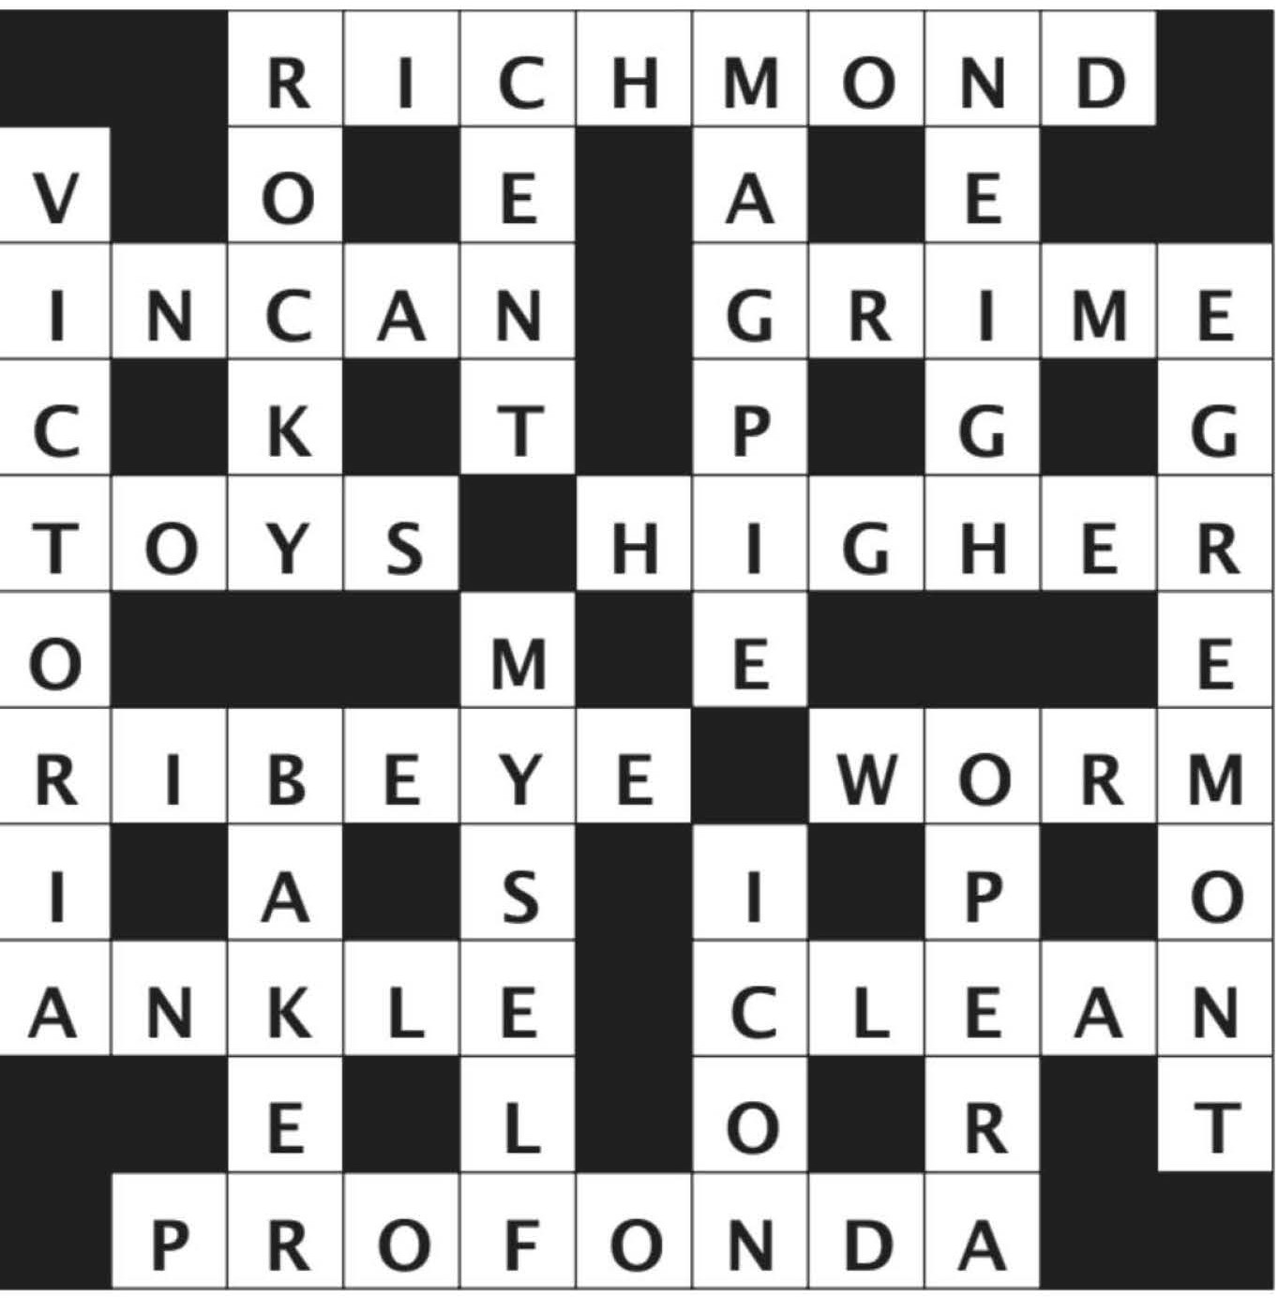

ANSWERS FOR ISSSUE #4

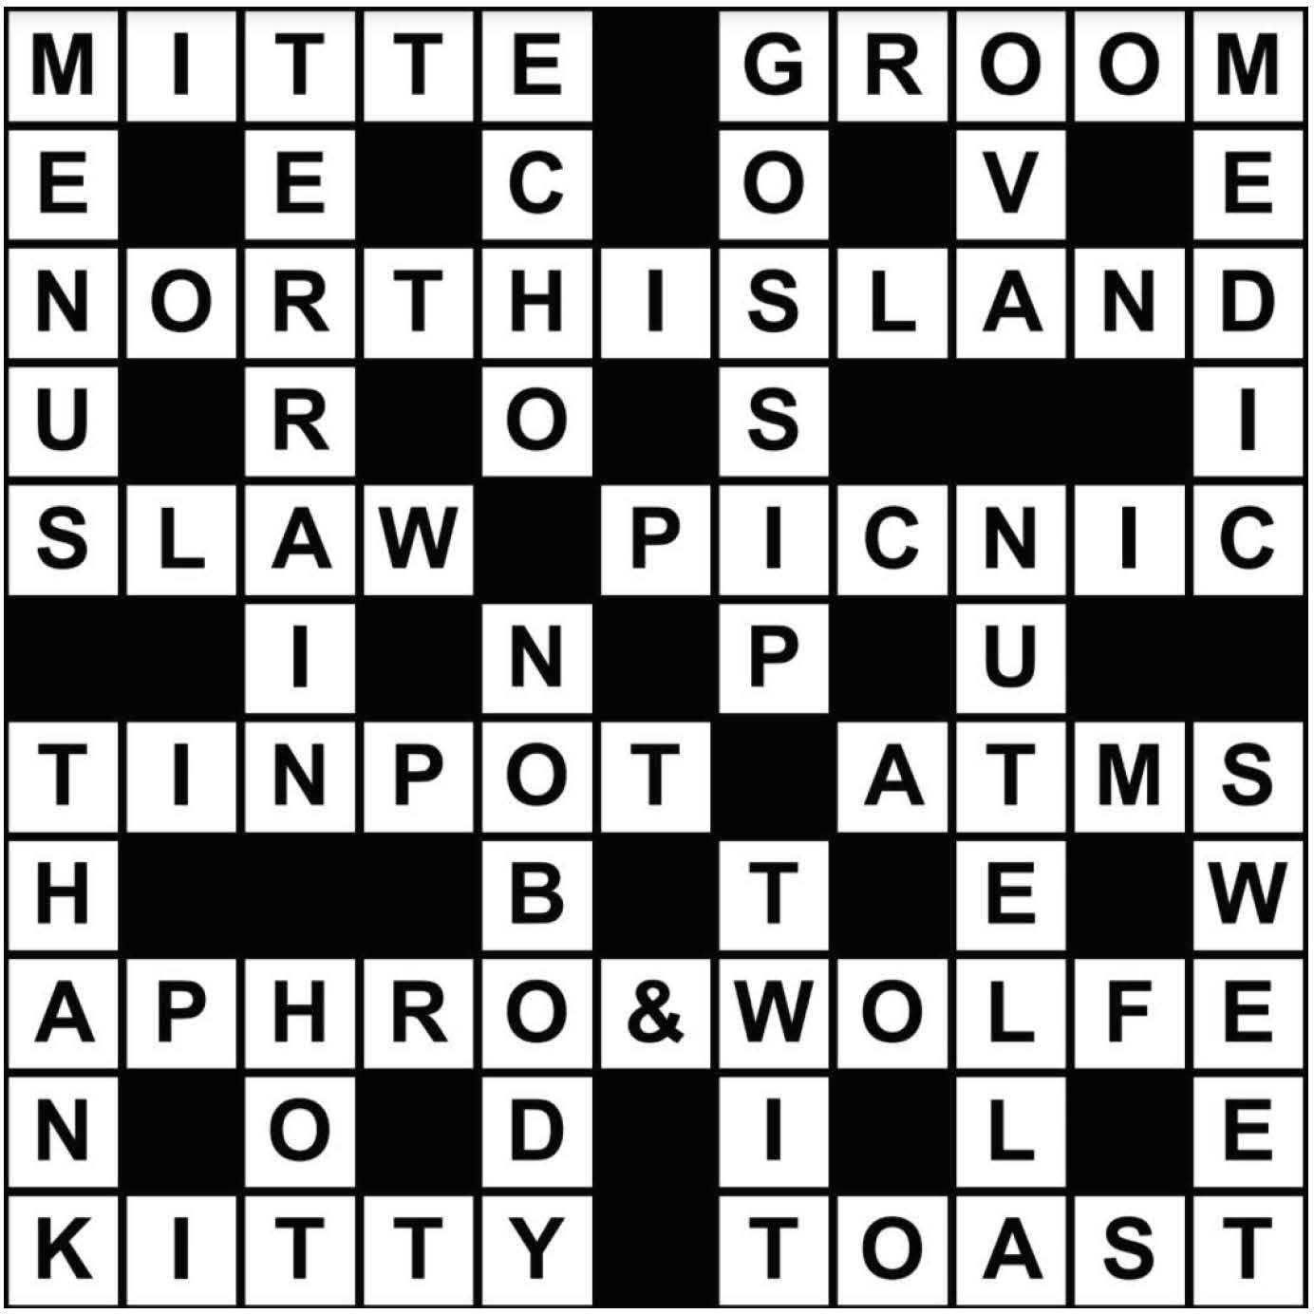

ANSWERS FOR ISSSUE #6
ANSWERS FOR ISSSUE #3

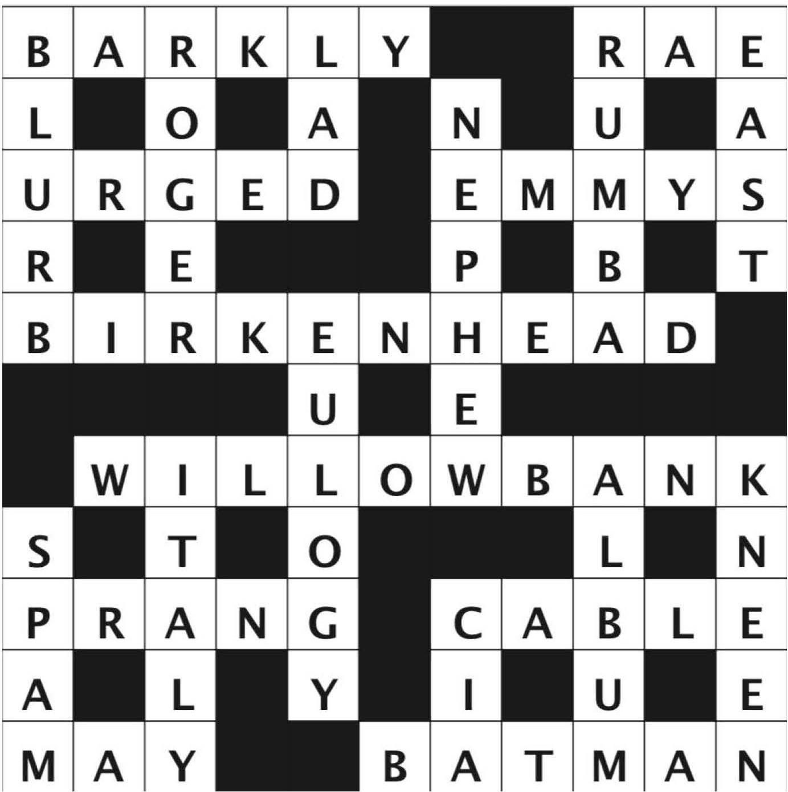

ANSWERS FOR ISSSUE #5

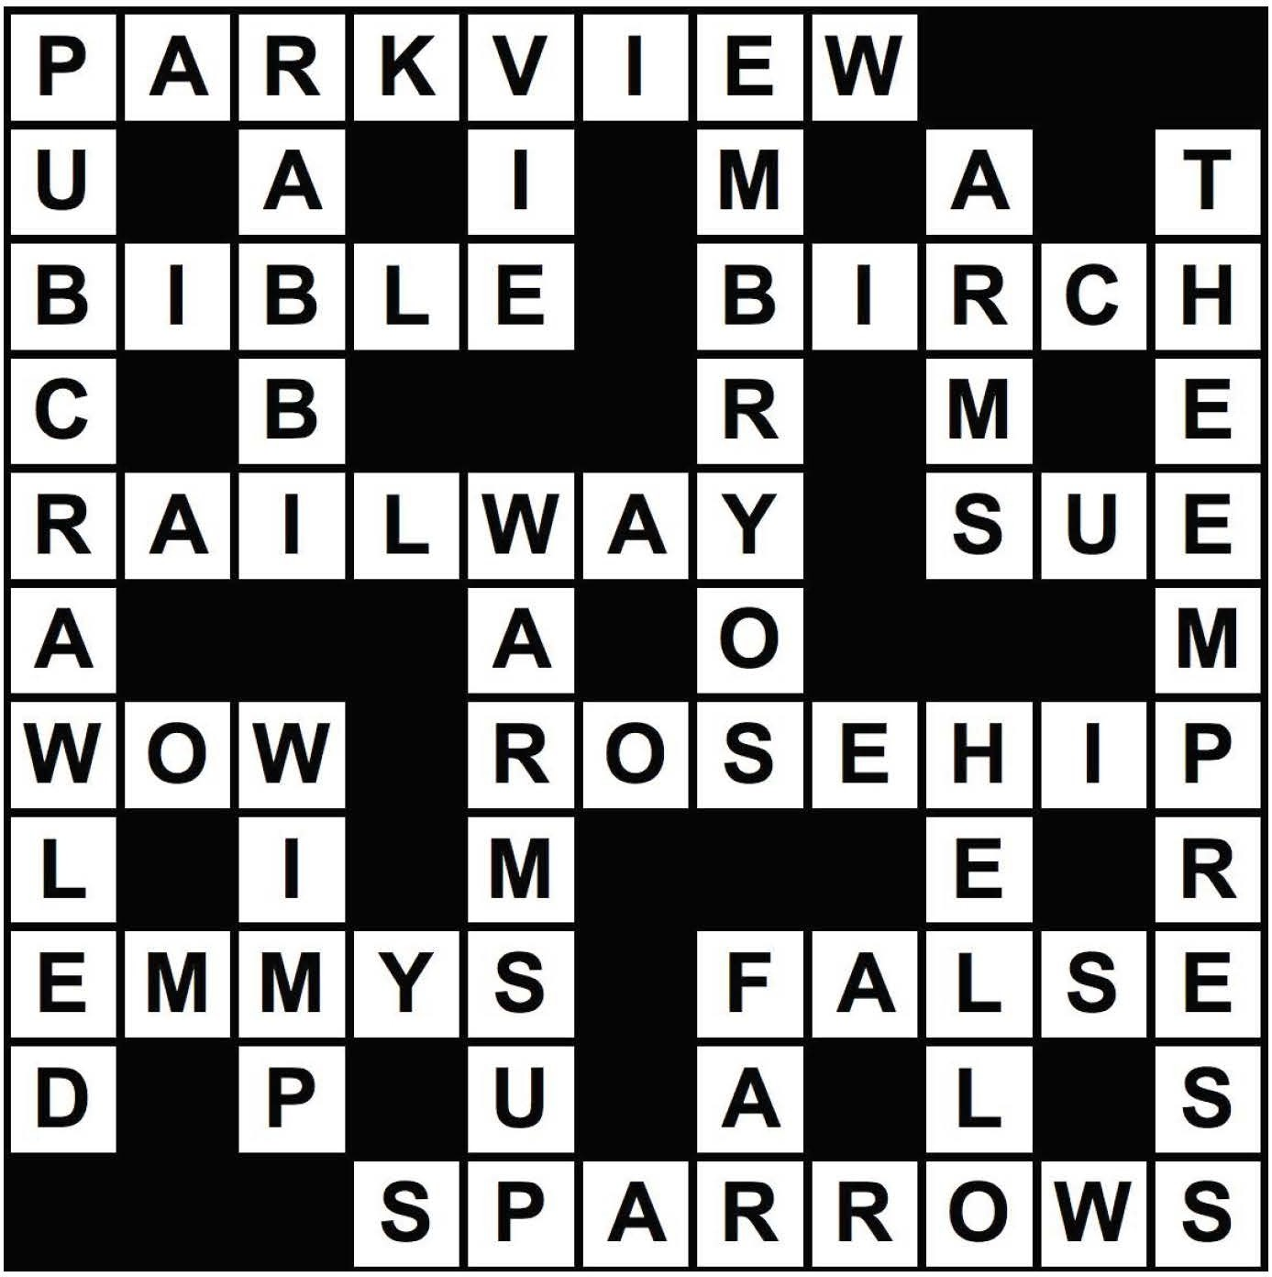

ANSWERS FOR ISSSUE #7

